Design a webpage (usage of typography)

**Index.html**

<!DOCTYPE html>

<html>

<head>

<title>Newers News</title>

<link rel="stylesheet" type="text/css" href="style.css">

<meta name="viewport" content="width=device-width, initial-scale=1.0">

</head>

<body>

<div class="container">

<header>

<img src="images/logo.jpeg" alt="logo" id="logo">

<h1 id="header-font">Newer Times</h1>

</header>

<div class="headline">

<div class="headline-border">

</div>

<p>BUZZ &#64; TO THE NEW</p>

</div>

<section>

<div class="section-text">

<h3>To the new organizes GeekCombat, a 2-day hackathon</h3>

<p>Lorem Ipsum is simply dummy text of the printing and typesetting industry. Lorem Ipsum has been the industry's standard dummy text ever since the 1500s, when an unknown printer took a galley of type and scrambled it to make a type specimen book. It has survived not only five centuries, but also the leap into electronic typesetting, remaining essentially unchanged. It was popularised in the 1960s with the release of Letraset sheets containing Lorem Ipsum passages, and more recently with desktop publishing software like Aldus PageMaker including versions of Lorem Ipsum.</p>

</div>

<div class="images-div">

<div class="images-div-left">

<img src="images/gallery_image_left.jpg">

</div>

<div class="images-div-right">

<div class="images-div-right-top">

<img src="images/gallery_image_right_top.jpg">

</div>

<div class="images-div-right-bottom">

<img src="images/gallery_image_right_bottom.jpg">

</div>

</div>

</div>

<div class="image-description">

<div class="image-description-left">

<h3>Lorem ipsum dolor sit amet, consectetur adipisicing elit. Aut ex in magni molestias mollitia natus numquam odio.</h3>

<p>Lorem ipsum dolor sit amet, consectetur adipisicing elit. Consequuntur deserunt magnam minus nesciunt nihil non praesentium quo rem repellat. Doloribus harum id ipsa magni provident quasi quibusdam, quis rerum temporibus.</p>

</div>

<div class="image-description-right">

<h3>Lorem ipsum dolor sit amet, consectetur adipisicing elit. Aut ex in magni molestias mollitia natus numquam odio.</h3>

<p>Lorem ipsum dolor sit amet, consectetur adipisicing elit. Consequuntur deserunt magnam minus nesciunt nihil non praesentium quo rem repellat. Doloribus harum id ipsa magni provident quasi quibusdam, quis rerum temporibus.</p>

</div>

</div>

</section>

</div>

<div class="headline-center">

<div class="headline-center-left">

<p>WE ARE <br><spam class="headline-gradient">MAKING <br>HEADLINES</spam></p>

</div>

<div class="headline-center-right">

<p>Lorem ipsum dolor sit amet, consectetur adipisicing elit. Ab aliquid aspernatur, aut consequuntur, dicta ducimus fugit hic illo. Lorem ipsum dolor sit amet, consectetur adipisicing elit. Ab adipisci asperiores aspernatur consectetur doloremque, dolores doloribus dolorum hic impedit inventore laudantium optio perspiciatis porro quis repellendus reprehenderit soluta temporibus veritatis!</p>

</div>

</div>

<div class="container">

<div class="headline">

<div class="headline-border"></div>

<p>4 Blogs You Should Read</p>

</div>

<div class="blog-content">

<div class="blog-content-main">

<div class="blog-content-left">

<h2>Deploy Code using AWS CodeDeploy and Github</h2>

<p>by Ranvijay Jamwal</p>

<h3>he much talked about AWS Codedeploy is used as a daily deployment...</h3>

<p class="read-more">read more</p>

</div>

<div class="blog-content-right">

<h2>Deploy Code using AWS CodeDeploy and Github</h2>

<p>by Ranvijay Jamwal</p>

<h3>he much talked about AWS Codedeploy is used as a daily deployment...</h3>

<p class="read-more">read more</p>

</div>

</div>

<div class="blog-content-main">

<div class="blog-content-left">

<h2>Deploy Code using AWS CodeDeploy and Github</h2>

<p>by Ranvijay Jamwal</p>

<h3>he much talked about AWS Codedeploy is used as a daily deployment...</h3>

<p class="read-more">read more</p>

</div>

<div class="blog-content-right">

<h2>Deploy Code using AWS CodeDeploy and Github</h2>

<p>by Ranvijay Jamwal</p>

<h3>he much talked about AWS Codedeploy is used as a daily deployment...</h3>

<p class="read-more">read more</p>

</div>

</div>

</div>

</div>

<div class="footer-banner">

<div class="footer-banner-left">

<p>NEW <br><spam class="footer-gradient">CLIENT <br>ACQUISITIONS</spam></p>

</div>

<div class="footer-banner-right">

<p>Lorem ipsum dolor sit amet, consectetur adipisicing elit. Ab aliquid aspernatur, aut consequuntur, dicta ducimus fugit hic illo. Lorem ipsum dolor sit amet, consectetur adipisicing elit. Ab adipisci asperiores aspernatur consectetur doloremque, dolores doloribus dolorum hic impedit inventore laudantium optio perspiciatis porro quis repellendus reprehenderit soluta temporibus veritatis!</p>

</div>

</div>

<footer class="footer-main">

<div class="social-icon">

<img src="images/facebook_icon.png" alt="Facebook social icon">

<img src="images/linkedin_icon.png" alt="Linkedin social icon">

<img src="images/twitter_icon.png" alt="Twitter social icon">

</div>

<div class="footer-content">

<h3>TO THE NEW</h3>

<p>For Sharing your feedback on this newsletter,<br> please email us at: newertimes@tothenew.com</p>

</div>

</footer>

</body>

</html>

sytle.css

body{

width: 100%;

margin: 0;

padding: 0;

background-color: gray;

}

.container{

margin: 20px 20px 0px 20px;

background-color: white;

padding: 0 100px;

position: relative;

}

header{

width: 100%;

border-bottom: 1px solid gray;

}

#logo{

width: 150px;

height: 150px;

}

#header-font{

text-transform: uppercase;

font-size: 100px;

margin: 18px;

float: right;

text-align: right;

letter-spacing: 8px;

background: linear-gradient(to right, #c2008f 0%, #490099 100%);

-webkit-background-clip: text;

-webkit-text-fill-color: transparent;

}

.headline{

width: 100%;

position: relative;

height: 50px;

display: flex;

justify-content: center;

align-items: center;

}

.headline-border{

border: 1px solid black;

height: 40px;

width: 200px;

}

.headline p{

background-color: white;

font-size: 22px;

position: absolute;

top: -10px;

}

.section-text h3{

font-size: 22px;

}

.section-text p{

line-height: 1.5em;

text-align: justify;

}

.images-div{

display: flex;

}

.images-div-left {

margin-right:20px;

}

.images-div-right {

margin-left:20px;

}

.images-div-right-top{

padding-bottom: 10px;

}

.images-div-right-bottom{

padding-top: 10px;

}

.images-div-left img{

width: 500px;

height: 500px;

}

.images-div-right img{

width: 500px;

height: 240px;

}

.image-description {

display: flex;

text-align: justify;

}

.image-description-left{

margin-right: 20px;

}

.image-description-right{

margin-left: 20px;

}

.headline-center{

margin: 0px 110px;

display: flex;

color: #fff;

}

.headline-center-left{

width: 100%;

font-size: 40px;

font-weight: bold;

letter-spacing: 5px;

color:#000;

margin-left: 5px;

}

.headline-gradient{

color: #fff;

background: linear-gradient(to right, #c2008f 0%, #490099 100%);

}

.headline-center-right{

width: 100%;

text-align:justify;

padding: 40px 0 0 35px;

}

.blog-content{

display: flex;

letter-spacing: 2px;

text-align: justify;

}

.blog-content .blog-content-main{

margin-right: 20px ;

margin-left: 20px;

}

.blog-content-main h3{

color: #909385;

}

.blog-content-main p{

font-weight: bold;

}

.read-more{

color: #ff009a;

}

.footer-banner{

background: linear-gradient(to right, #c2008f 0%, #490099 100%);

display: flex;

padding: 0 120px;

color: #fff;

}

.footer-banner-left{

width: 100%;

font-size: 40px;

font-weight: bold;

letter-spacing: 5px;

margin-left: 5px;

}

.footer-gradient{

background-color: #fff;

color: #ff009a;

}

.footer-banner-right{

width: 100%;

text-align:justify;

padding: 40px 0 0 35px;

}

footer {

background-color: #fff;

padding: 20px 0px;

}

.social-icon{

text-align: center;

}

.footer-content{

text-align: center;

}

@media only screen and (max-width: 600px){

.container{

margin: 0;

padding: 20px;

}

#logo{

padding-left: 100px;

}

.images-div{

display: block;

margin: 0px;

}

.images-div img{

width: 100%;

}

.images-div-left{

margin: 0;

}

.images-div-right{

margin: 0;

}

.image-description{

display: block;

}

.image-description-left{

margin: 0;

}

.image-description-right{

margin: 0;

}

.headline-center{

display: block;

padding: 0;

margin: 0;

}

.headline-center-left{

margin: 0;

}

.headline-center-right{

margin: 0;

padding: 0;

}

#header-font{

text-transform: uppercase;

font-size: 30px;

float: right;

background: linear-gradient(to right, #c2008f 0%, #490099 100%);

-webkit-background-clip: text;

-webkit-text-fill-color: transparent;

}

.blog-content{

display: block;

}

.footer-banner{

display: block;

padding: 0;

}

.footer-banner p{

padding: 0;

margin: 0;

}

.footer-banner-left{

margin: 0;

}

.footer-banner-right{

margin: 0;

padding: 0;

}

footer {

background-color: #fff;

}

}

**Output:**

Desktop view

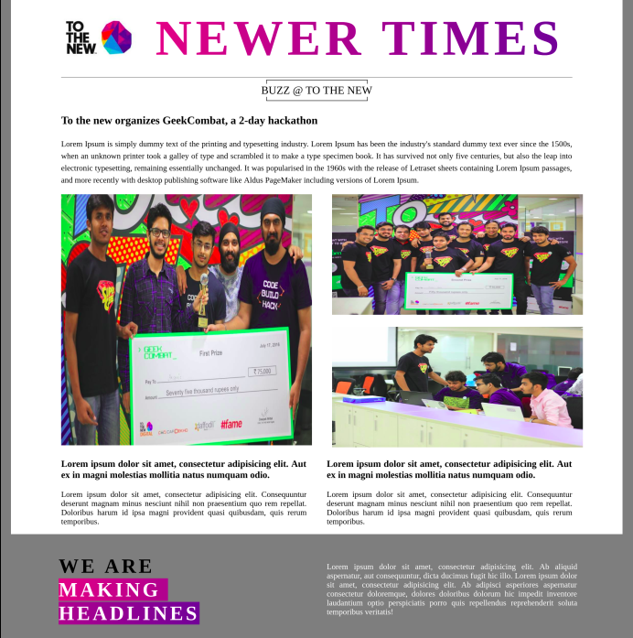

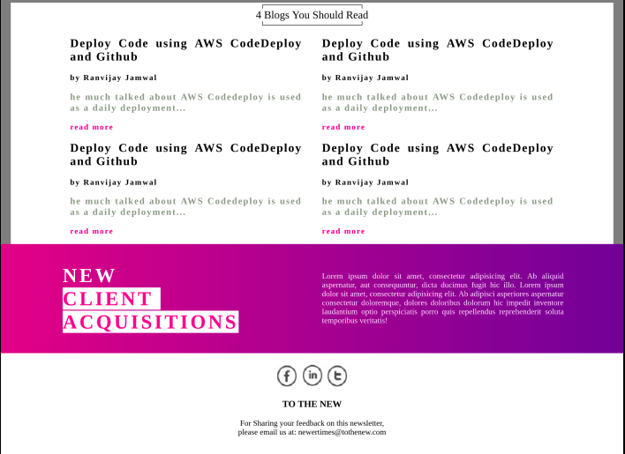

**Mobile Output**

